Clean Code Principles - Follow Proper Structure
# Source: AI Source: Provided by: [Data Path: Persons Table -> ID Column: 1, Name_En Column: Motasem Essam] -> From: [Chatgpt (GPT‑5 Mini)] on [12/9/2025]
Following proper structure means organizing your code in a clear, logical, and predictable way across files, classes, and the whole project.
👉 A well-structured codebase is easy to navigate, understand, and scale.

🔑 Why It Matters
# Source: AI Source: Provided by: [Data Path: Persons Table -> ID Column: 1, Name_En Column: Motasem Essam] -> From: [Chatgpt (GPT‑5 Mini)] on [12/9/2025]
- Makes code easier to read and maintain
- Helps developers find things quickly
- Improves scalability for large projects
- Reduces confusion and errors

❌ Bad Example (Poor Structure)
# Source: AI Source: Provided by: [Data Path: Persons Table -> ID Column: 1, Name_En Column: Motasem Essam] -> From: [Chatgpt (GPT‑5 Mini)] on [12/9/2025]
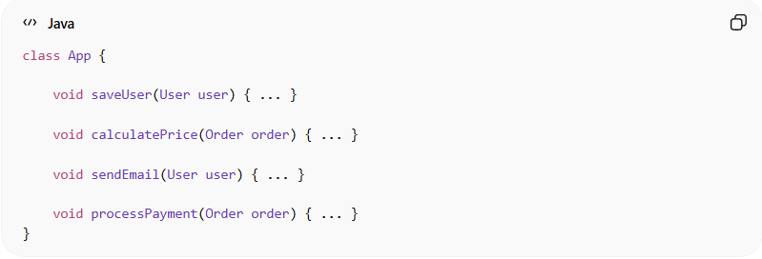
class App {

void saveUser(User user) { ... }

void calculatePrice(Order order) { ... }

void sendEmail(User user) { ... }

void processPayment(Order order) { ... }
}
👉 Problems:
- Unrelated logic mixed together
- No clear responsibility
- Hard to maintain

✅ Good Example (Proper Structure)
# Source: AI Source: Provided by: [Data Path: Persons Table -> ID Column: 1, Name_En Column: Motasem Essam] -> From: [Chatgpt (GPT‑5 Mini)] on [12/9/2025]
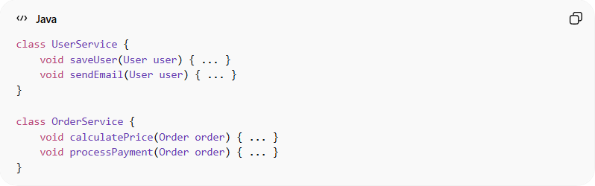
class UserService {
void saveUser(User user) { ... }
void sendEmail(User user) { ... }
}

class OrderService {
void calculatePrice(Order order) { ... }
void processPayment(Order order) { ... }
}
👉 Benefits:
- Each class has a clear responsibility
- Logic is grouped correctly
- Easier to maintain and extend

📂 Project Structure Example
# Source: AI Source: Provided by: [Data Path: Persons Table -> ID Column: 1, Name_En Column: Motasem Essam] -> From: [Chatgpt (GPT‑5 Mini)] on [12/9/2025]
❌ Bad
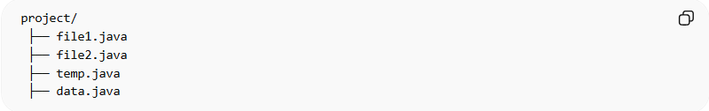
project/
├── file1.java
├── file2.java
├── temp.java
├── data.java
👉 No organization, unclear purpose

✅ Good
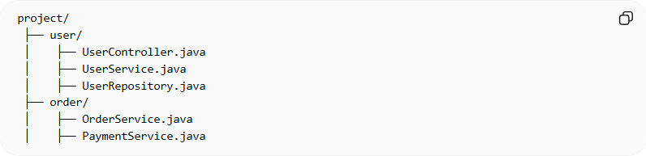
project/
├── user/
│ ├── UserController.java
│ ├── UserService.java
│ ├── UserRepository.java
├── order/
│ ├── OrderService.java
│ ├── PaymentService.java
👉 Clear structure and grouping

🧭 Best Practices

1. One Responsibility per Class
# Source: AI Source: Provided by: [Data Path: Persons Table -> ID Column: 1, Name_En Column: Motasem Essam] -> From: [Chatgpt (GPT‑5 Mini)] on [12/9/2025]
- Each class should focus on one thing
❌ Bad
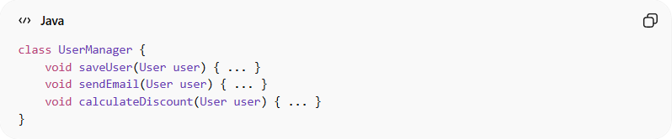
class UserManager {
void saveUser(User user) { ... }
void sendEmail(User user) { ... }
void calculateDiscount(User user) { ... }
}
👉 Problems:
- Multiple responsibilities (saving, emailing, pricing)
- Hard to maintain and test

✅ Good
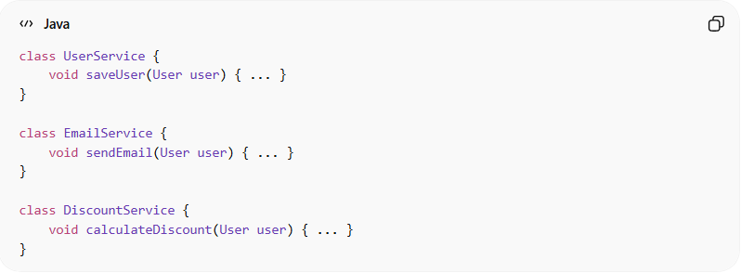
class UserService {
void saveUser(User user) { ... }
}
class EmailService {
void sendEmail(User user) { ... }
}
class DiscountService {
void calculateDiscount(User user) { ... }
}
👉 Each class has one clear responsibility

2. Logical Grouping
# Source: AI Source: Provided by: [Data Path: Persons Table -> ID Column: 1, Name_En Column: Motasem Essam] -> From: [Chatgpt (GPT‑5 Mini)] on [12/9/2025]
- Group related files and functions together
❌ Bad
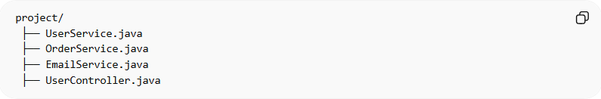
project/
├── UserService.java
├── OrderService.java
├── EmailService.java
├── UserController.java
👉 Everything mixed together

✅ Good
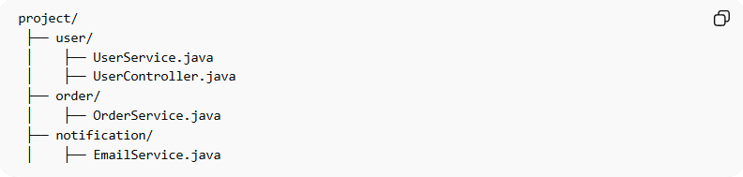
project/
├── user/
│ ├── UserService.java
│ ├── UserController.java
├── order/
│ ├── OrderService.java
├── notification/
│ ├── EmailService.java
👉 Related code is grouped logically

3. Clear Layers or Domains
# Source: AI Source: Provided by: [Data Path: Persons Table -> ID Column: 1, Name_En Column: Motasem Essam] -> From: [Chatgpt (GPT‑5 Mini)] on [12/9/2025]
- Use layers (Controller → Service → Repository)
- Or organize by feature/domain
❌ Bad
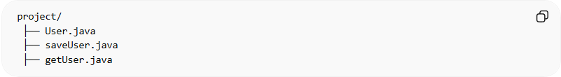
project/
├── User.java
├── saveUser.java
├── getUser.java
✅ Good
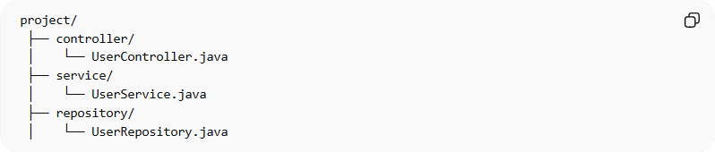
project/
├── controller/
│ └── UserController.java
├── service/
│ └── UserService.java
├── repository/
│ └── UserRepository.java
✅ Also Good (Domain-Based)
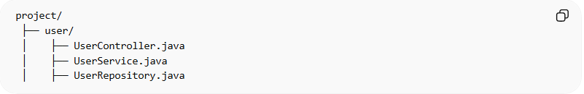
project/
├── user/
│ ├── UserController.java
│ ├── UserService.java
│ ├── UserRepository.java
👉 Both are valid → choose one and stay consistent

4. Keep Files Manageable
# Source: AI Source: Provided by: [Data Path: Persons Table -> ID Column: 1, Name_En Column: Motasem Essam] -> From: [Chatgpt (GPT‑5 Mini)] on [12/9/2025]
- Avoid very large files
- Split when needed
❌ Bad
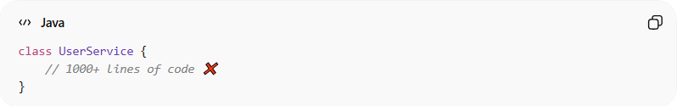
class UserService {
// 1000+ lines of code ❌
}
👉 Problems:
- Hard to read
- Hard to maintain
- Hard to test

✅ Good
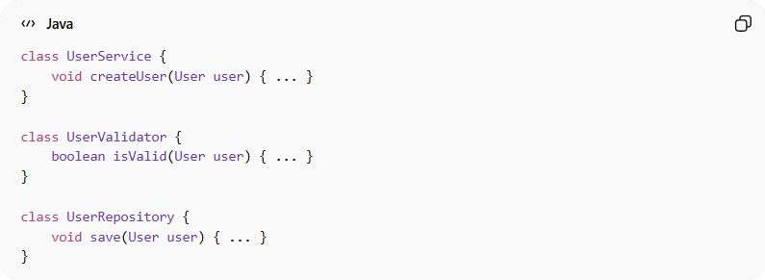
class UserService {
void createUser(User user) { ... }
}
class UserValidator {
boolean isValid(User user) { ... }
}
class UserRepository {
void save(User user) { ... }
}
👉 Split into smaller, focused files

5. Predictable Structure
# Source: AI Source: Provided by: [Data Path: Persons Table -> ID Column: 1, Name_En Column: Motasem Essam] -> From: [Chatgpt (GPT‑5 Mini)] on [12/9/2025]
- Follow consistent patterns across the project
❌ Bad
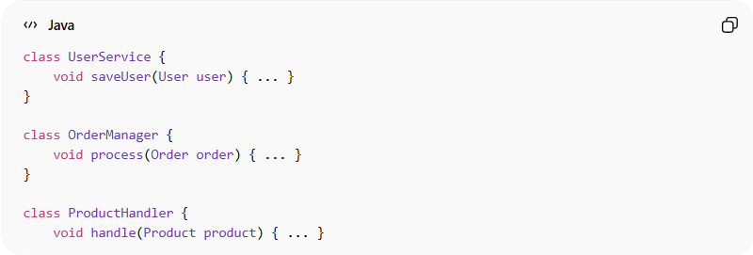
class UserService {
void saveUser(User user) { ... }
}
class OrderManager {
void process(Order order) { ... }
}
class ProductHandler {
void handle(Product product) { ... }
👉 Inconsistent naming and structure
✅ Good
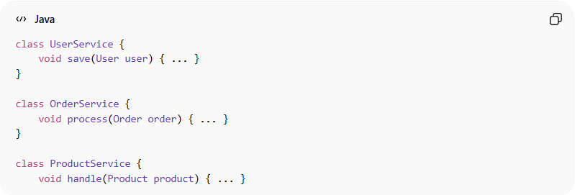
class UserService {
void save(User user) { ... }
}
class OrderService {
void process(Order order) { ... }
}
class ProductService {
void handle(Product product) { ... }
👉 Consistent naming and structure

💡 Key Idea
# Source: AI Source: Provided by: [Data Path: Persons Table -> ID Column: 1, Name_En Column: Motasem Essam] -> From: [Chatgpt (GPT‑5 Mini)] on [12/9/2025]
A developer should understand your project structure without asking questions.

🚫 Common Mistakes
# Source: AI Source: Provided by: [Data Path: Persons Table -> ID Column: 1, Name_En Column: Motasem Essam] -> From: [Chatgpt (GPT‑5 Mini)] on [12/9/2025]
- Mixing unrelated logic in one class
- Random file organization
- Huge “God classes”
- No clear separation of concerns

🧾 Summary
# Source: AI Source: Provided by: [Data Path: Persons Table -> ID Column: 1, Name_En Column: Motasem Essam] -> From: [Chatgpt (GPT‑5 Mini)] on [12/9/2025]
Following proper structure helps you:
- Build clean and scalable systems
- Improve readability and navigation
- Reduce complexity and confusion

